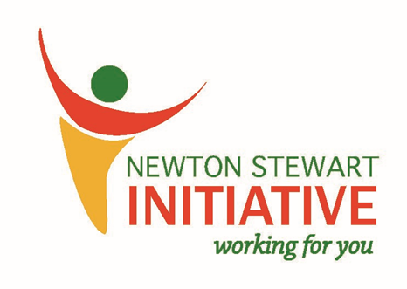

NSI Community Shop Volunteer Form
Newton Stewart Initiative is a community organisation with charitable status, reformed in February 2014 to regenerate our town, involving as many people and groups as possible. NSI aims to develop community facilities, support community led initiatives, businesses and regeneration projects, youth, arts and sports projects and any other project that benefits the community living and working in and around Newton Stewart.
The Community Shop was opened in 2017 in the old tourist information building to raise funds for NSI projects, as well as some of the proceeds going to local groups and organisations. It is staffed entirely by volunteers and stocked by donations from people in the community.

Name of Applicant

Date of Birth

Address

Contact Number

Email Address

Emergency Contact Information

Why would you like to become a volunteer?

Do you have any relevant experience? If so, detail it below:

What days would you be available to volunteer? Shifts are 10:00-13:00 (morning) and 13:00-16:00 (afternoon) from Monday-Saturday.

Please return completed form to the Community Shop and we will get back to you as soon as possible. Thank you so much for getting involved!

