Newton Stewart Initiative Autumn Newsletter

We are pleased to get the Autumn Newsletter out to all our members and other associates. It has been a busy few months for us with reporting back to funders about what we have done, applying for more funding, hiring new staff and generally keeping the Newton Stewart Centre up and running.

Staff/board changes
We are pleased to introduce Lindsay to our team. Lindsay will be taking over Olivia’s role of Project Support Worker. You can get a hold of Lindsay by emailing her lindsay@newtonstewartinitiative.net or by phone/text 07949 222245

We are also pleased to announce that we have two new Trustees on board! Gavin McHallum and Chrissie Hill have both joined the NSI board to give their valuable input into our projects. We look forward to working with and getting their input in all the work NSI is doing for the Community.
If you are interested in becoming a Trustee, please contact Katrina at info@newtonstewartinitiative.net or phone the office phone on 01671 401449
Amazing Summer Events update
We held three different summer events (Sports Day, Picnic in the Park & Outdoor Cinema screenings with the help from funding from the Amazing Summer Fund and Community Led Funding. The events were aimed at young people and families and saw over 115 unique children and young people as well as their families (who have not been included in these numbers). Our main aims where to create events which were accessible and inclusive to all, free to attend with free food and had some user input.
We were very pleased with how the events turned out and got some great feedback and ideas for next year! We will be looking to apply for funding for summer events such as this and would like to welcome anyone who is interested to join our events sub-group to help decide and plan some amazing events for next summer. The event group is open to people aged 10 and up to 100!
If you are interested in joining the events group, please contact us on info@newtonstewartinitiative.net
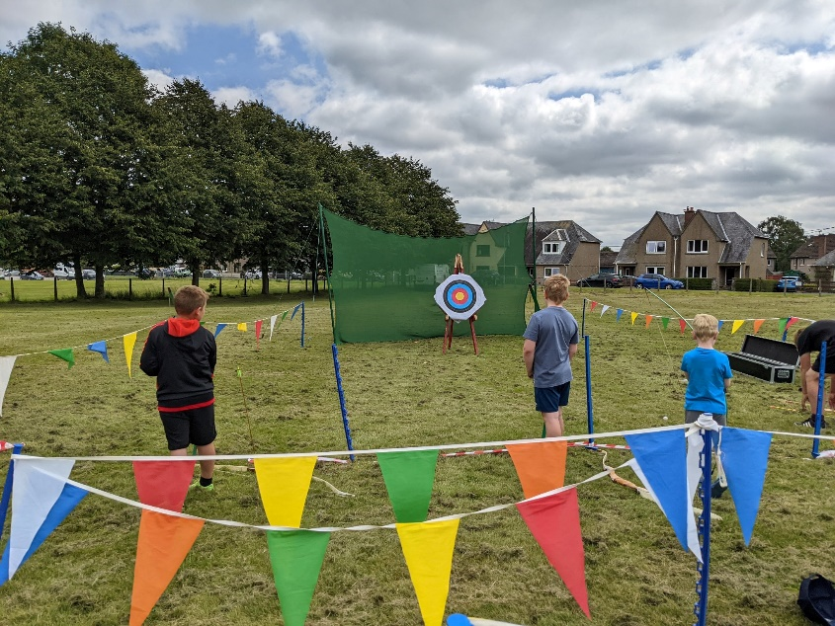
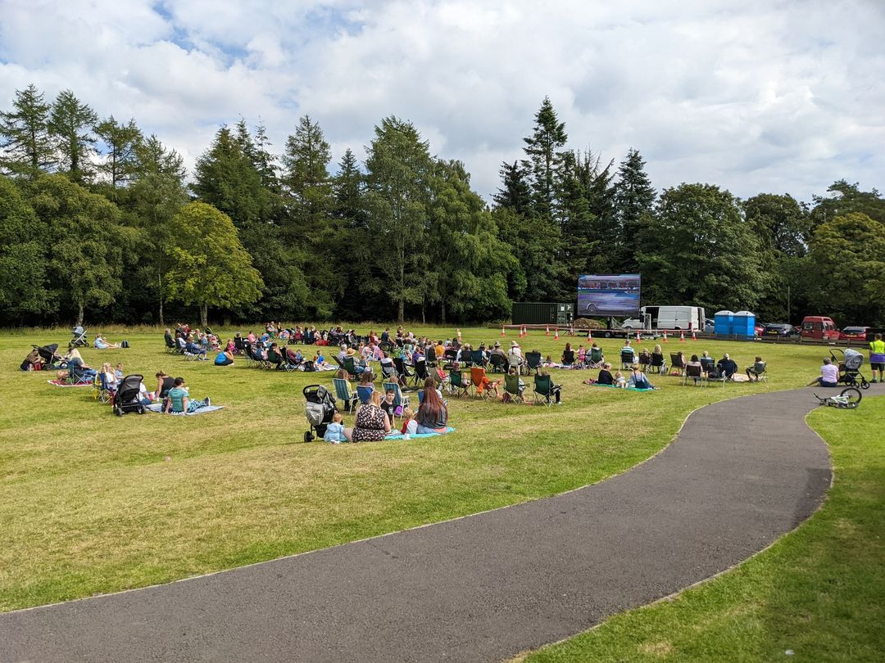
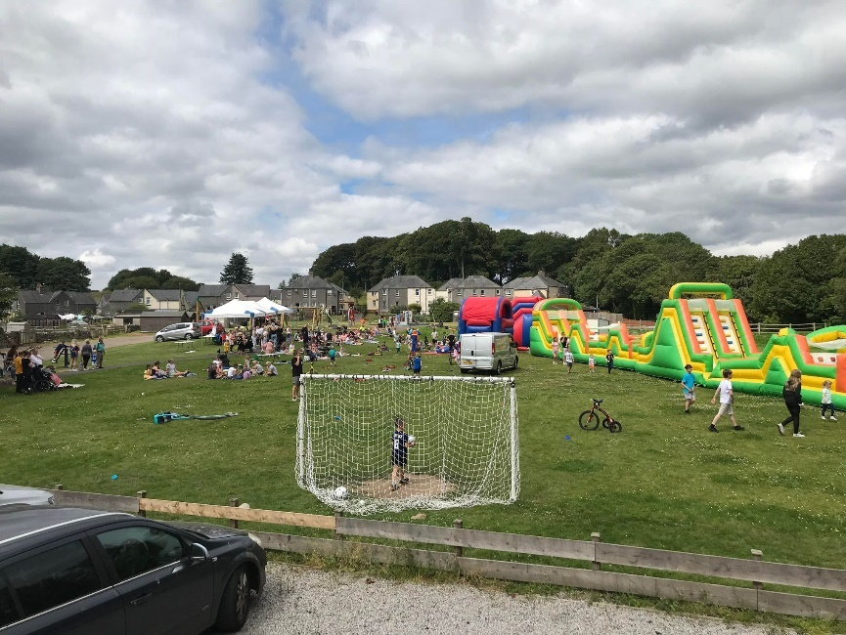
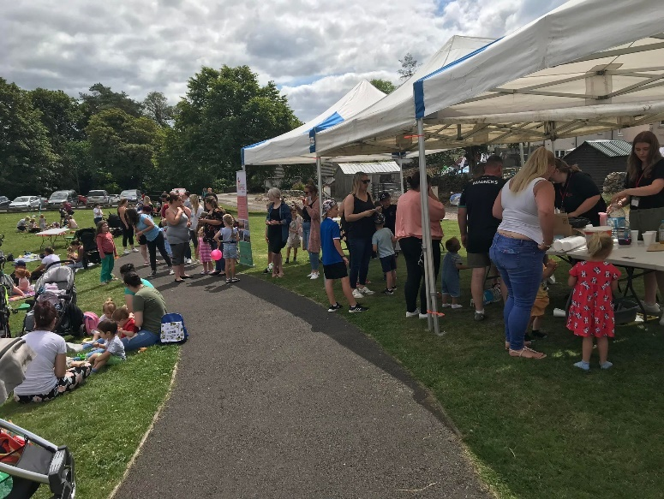
Newton Stewart Centre
We have had some new bookings lately which is great to see! We still have a few slots left on Tuesdays and Thursdays and at weekends. Just email info@newtonstewartinitiative.net to book or phone the Centre between 9 – 5
Youth Work
We made the difficult decision to stop running our youth group SPACE for now due to lack of numbers. We have recently been working in partnership with the local Public Health Improvement Team to carry out a survey based on health and wellbeing at the Douglas Ewart to gain some insight into whether there are any needs for specific initiatives or groups. We are also looking into the possibility of starting up some new youth work in the new year. If you feel there is a gap in youth work or have a bright idea, we would love to hear it!
Town Regeneration
We have had a town regeneration group running the last year, which has consisted of various groups coming together to discuss priorities and ideas on how to regenerate Newton Stewart with particular focus on the town center. If you are interested either as an individual or as a group, please get in touch for the latest meeting date! Meetings are usually held on a Thursday in the evening at the Newton Stewart Center.
Douglas Park update
We were delighted when in July we could announce the completion of the building of the Inclusive Play Park in Douglas Park, we were also overly happy when in early October the installation of the much sought-after benches was completed too!
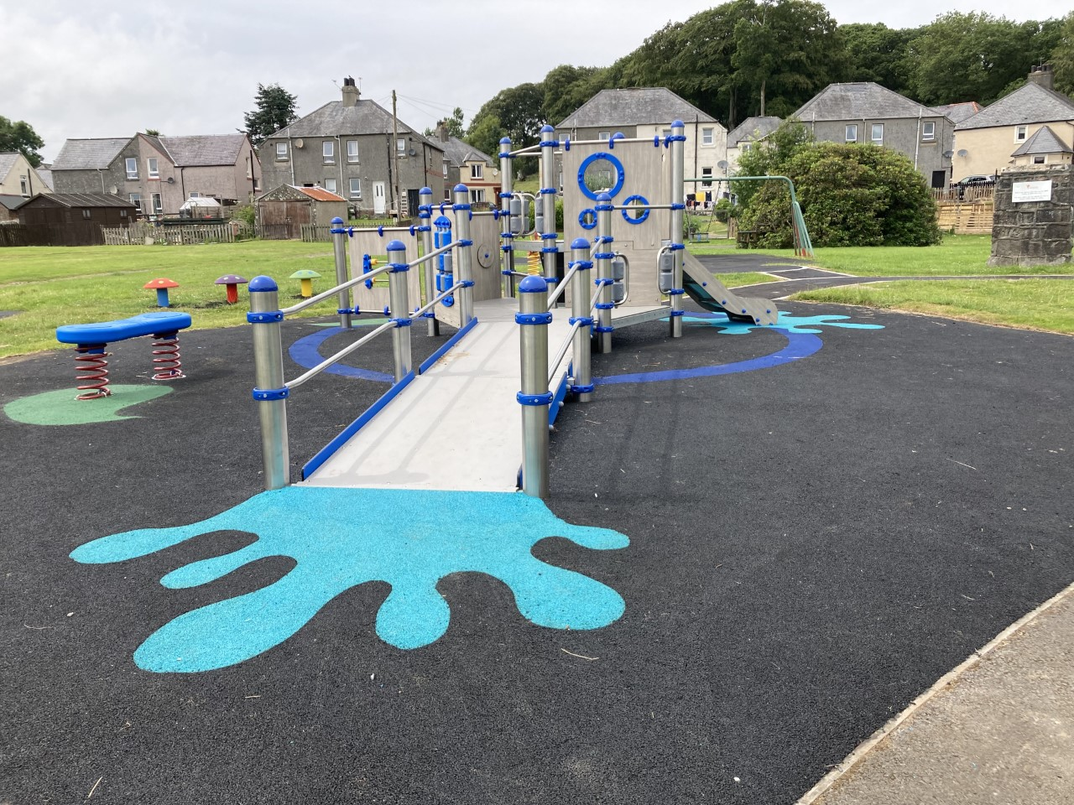
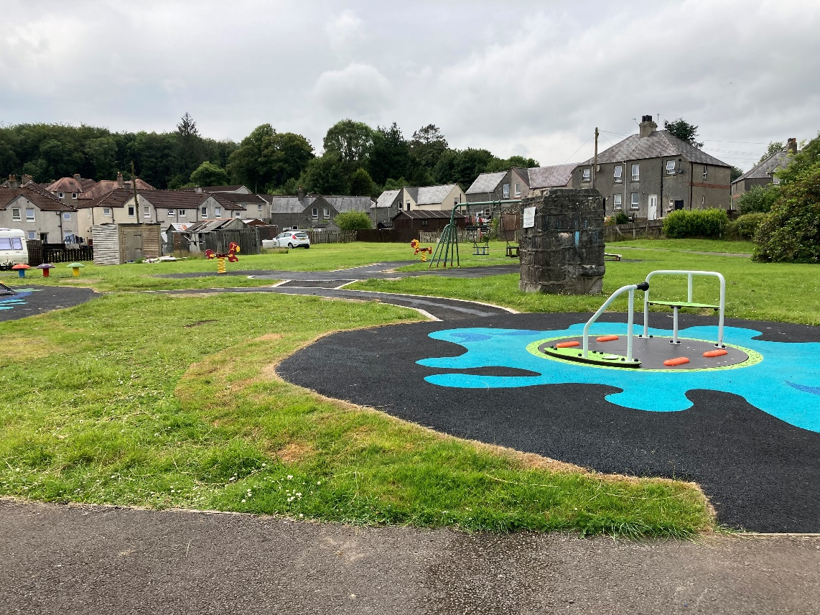
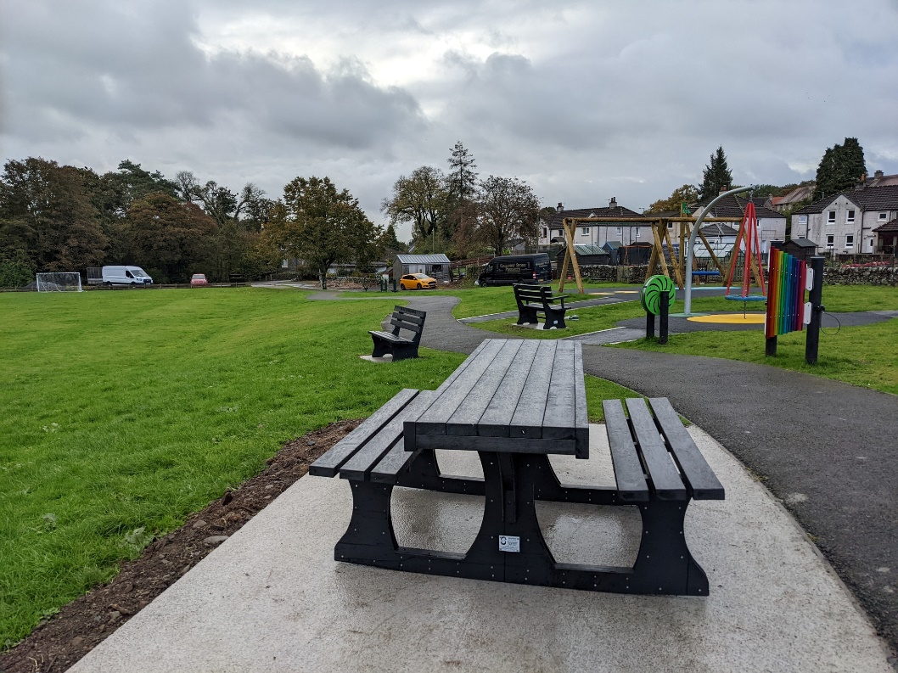
We are still working hard to get funding for the Changing Places toilet, which we hope to locate near where the container is currently situated. Funding wise we are still short of approx. £40,000 which we are working hard to get!
Community Shop
Our Community Shop at Dashwood Square is currently thriving with loads of bargains available, donated by people from near and far. We are currently on the lookout for some new volunteers to help cover shifts in the shop. Each shift is three hours long and is either a morning (10-1) or an afternoon shift (1-4). You don’t need any shop experience to be a volunteer, but the ability to work independently and as part of a team is desirable. Contact Linda on 07790 009265 or pop into the shop to find out more!
Our Community Shop grants have attracted quite a bit of attention from the community, which is great! The closing date for applications is 31st of October. If you require an application form, it can be picked up at the Community Shop between the opening hours of 10-4 Monday – Saturday.
Winter Fayre
We are delighted to be able to share that the Winter Fayre will indeed be running this year! So, hold off the 19th of November! We are looking for volunteers to help run the event, so if you have a few hours to spare, please let us know!
We have a range of various stallholders this year who will sell a variety of items from knitting to pottery to calendars! Refreshments will be available too, as well as raffles and a Santa’s grotto run by the Newton Stewart Players!
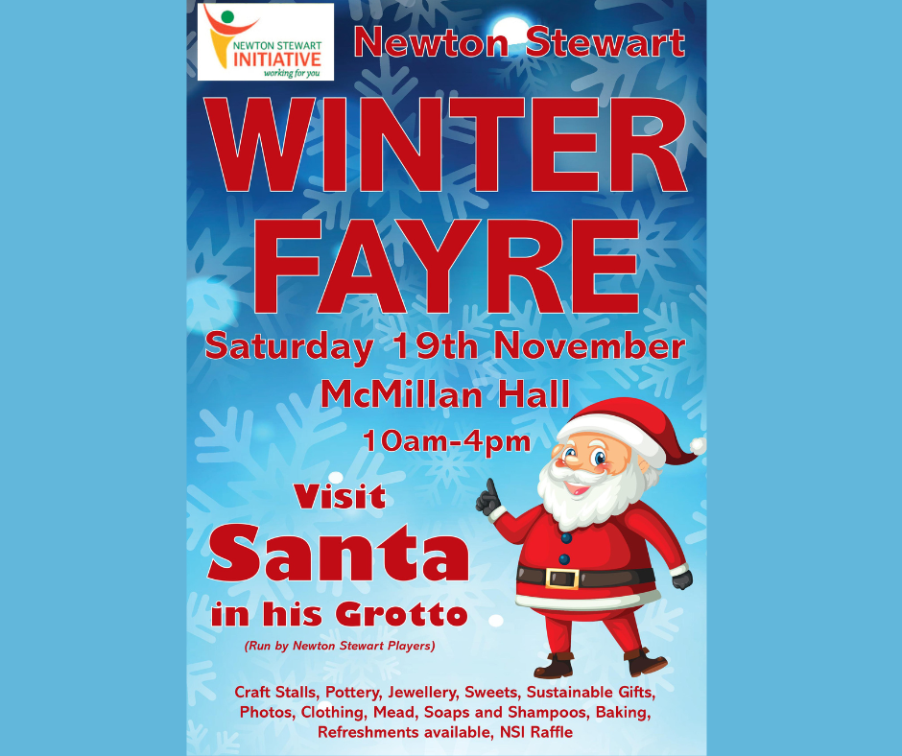
Competition time!
We currently have a little competition running for Halloween, were we are asking people to carve us a spooky, creative or classic pumpkin (or turnip). Entrants can send their pictures to us on info@newtonstewartinitiative.net or message our page. Deadline for entries is 31st of Oct. Prizes to be won!
Our friends Driftwood Cinema are holding outdoor cinema screenings at Kirroughtree on the 29th of October showing a range of horror movies. To book go to https://nowshowing.uk/?fbclid=IwAR03nqJd7pcU1BQyhms6DAaKXt85KKjyq5s6b8ST6rLAQRG0yJ41DKe0JoU they are also looking for volunteers to help steward people around etc. If you help at a film screening you will get a free ticket. Suitable for those over 15 years of age. If interested in volunteering please contact Matt at matt@driftwoodcinema.org
As always if you have an idea or view on what Newton Stewart Initiative could/should be doing then drop us a line!

